8.5” x 11” Event Poster Template – Option 4
The College of Arts and Sciences Office of Marketing and Communications has created and approved the template that adheres to brand and accessibility standards. To ensure consistency, all must use this template to promote the College of Arts and Sciences events, lectures, courses, etc.

How to use this template
This Microsoft Word event poster template makes it easy to create branded event promotions for print use only. Please use the following steps to customize your event poster.
- Please enter your information where it's indicated on the following few pages.
- Be sure to delete these instructions, designs you’re not using and any other highlighted or placeholder copy.
- Create a QR Code using the directions below to connect the poster with what you're promoting.
- Save your changes and print.
- For best results, print your poster through University Print Services, a UB preferred on-campus vendor with lower costs than outside vendors and experienced staff to help you. Learn more about printing color copies at the University Print Services website.

Please note:
The University at Buffalo and the College of Arts and Sciences are committed to ensuring accessibility for people with disabilities. We are continually improving the user experience for everyone and applying the relevant accessibility standards to ensure we provide equal access to all users. Please do not change the pre-established settings in the header and footer of this template. This includes the settings for font, line spacing, margins and colors in these regions, as well as the size and position of the brand extension mark. Keeping the same settings will ensure that this document complies with all brand and accessibility standards.
Poster Content Outline
Please include the following items when creating a poster using this template:
- Images: High quality, original JPG or PNG files. Look for images with movement, energy, diversity, pride symbols, etc. Please check out the UB Photo Database for photos.
- Event Title Header: Make it short and catchy, describing exactly what it is. E.g., Art Speaker Series, O’nigöëi:yo:h Thinking In Indian Gallery Exhibit or The Riviera, Exposed: An Ecohistory of Postwar Tourism and North African Labor.
- Subtitle: Provides further clarification of the title, if necessary. E.g., Presented by Professor Stephen Harp.
- Event Description: Approx. 2-5 sentences describing the event. Usually includes a call-to-action such as “attend,” “enroll,” “join,” etc.
- Event Schedule: Only necessary if the event has more than one component.
- Location: Almost always necessary.
- Date and Time: Almost always necessary.
- Contact Information: Department name,email address or phone number
- Website: If applicable (double-check URL). Don’t include https:// or the .html
- RSVP or Registration: If applicable and create a QR code for the registration link (see below for creating a free QR code).
- Cost: If applicable.
- Is this event open to the public? (If so, this is often noted somewhere on the poster. “Free and Open to the Public.” However, if a target audience is in mind, it doesn’t need to be included.)
- Sponsorship/Collaborators: Please include department names (including your department). E.g., Sponsored by: the Department of History and the College of Arts and Sciences.
- Additional Information: Does anything else need to be included in the final version?

QR Codes

What is a QR code?
The quick response, or QR, Code is a two-dimensional version of the Barcode able to link directly to a website with the scan of a mobile device.
Visit the HelloTech website to learn how to scan a QR Code >>

How to create a QR code?
Creating a QR Code couldn't be easier. Follow the directions below to get started.
- Visit QR Code Monkey to start building your free QR Code.
- Choose and copy the website URL you'll like your audience to visit when looking at your event poster.
- Paste the website URL under QR Content in the "Your URL" text field.
- Click the green "Create QR Code."
- Once the QR code generates, click the blue "Download PNG."
- Insert the QR Code by selecting the qr-code.png file from your download folder.

Poster and QR Code Best Practices
- Less is more. Think about the one action you'd like your audience to take while looking at your event poster, whether registering for an event or course or learning more about your content.
- Use UB Style Guide, a UB customized version of AP Style, as a reference when writing your event descriptions.
- Find high-resolution photos to use from SmugMug, UB's online photo database, for your poster. Learn how to download photos from SmugMug. Not finding what you're looking for? Check out the list of sites that have free to low costing images you can use on the Marketing and Communications website.
- You can access department-specific branded templates, lockups and more in the Department Branding Toolkit.

Print your poster on campus.
For best results, print your poster through University Print Services. This is UB's preferred, on-campus vendor with lower costs than outside vendors and experienced staff to help you. Learn more about printing color copies at the University Print Services website.

Poster Template Toolkit
Additional icons and graphics can be found on page 5 that can be added to the poster template below.

Photo Credit

Place your event series title here

Description of the series: Lorem ipsum dolor sit amet, phasellus ornare an et convallis adipiscing mi, pretium vitae sit qui, sollicitudin nulla, lacus commodo semper sit. Congue in, mi sed faucibus porttitor, odio dui at, lobortis elit dui arcu tellus arcu sed. Acus et unus scelerisque nibh orci risus libero id, vivamus est sem odio ac in, risus libero id mollis fusce.
For more information, visit arts-sciences.buffalo.edu
or scan the QR code.

Upcoming Events
Event One
DATE: Jan. 00, 2023
TIME: 2-5:30 p.m.
LOCATION: Clemens Hall
- - - - - - - - - - - - - - - - - - - - - - - - - - - - - - -
Event Two
DATE: Jan. 00, 2023
TIME: 2-5:30 p.m.
LOCATION: Clemens Hall
- - - - - - - - - - - - - - - - - - - - - - - - - - - - - - -
Event Three
DATE: Jan. 00, 2023
TIME: 2-5:30 p.m.
LOCATION: Clemens Hall
- - - - - - - - - - - - - - - - - - - - - - - - - - - - - - -
Event Four
DATE: Jan. 00, 2023
TIME: 2-5:30 p.m.
LOCATION: Clemens Hall
- - - - - - - - - - - - - - - - - - - - - - - - - - - - - - -
Event Five
DATE: Jan. 00, 2023
TIME: 2-5:30 p.m.
LOCATION: Clemens Hall
- - - - - - - - - - - - - - - - - - - - - - - - - - - - - - -
Event Six
DATE: Jan. 00, 2023
TIME: 2-5:30 p.m.
LOCATION: Clemens Hall
- - - - - - - - - - - - - - - - - - - - - - - - - - - - - - -
Event Seven
DATE: Jan. 00, 2023
TIME: 2-5:30 p.m.
LOCATION: Clemens Hall
- - - - - - - - - - - - - - - - - - - - - - - - - - - - - - -

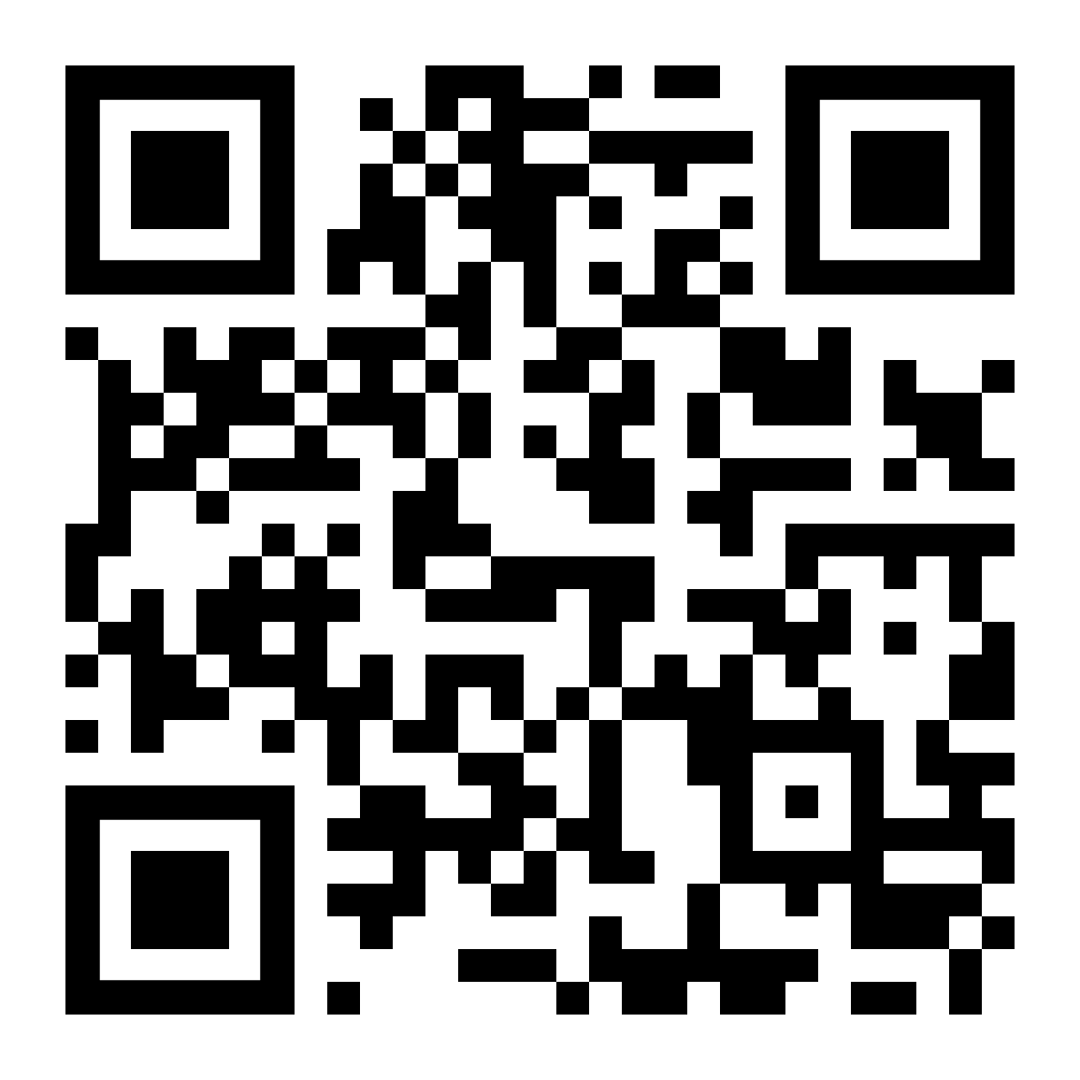

event
registration isn’t required
EVENT SPONSORS: Event Sponsor One, Event Sponsor Two and Event Sponsor Three

Poster Template Toolkit

ENTER YOUr CALLOUT COPY HERE
ENTER YOUr CALLOUT COPY HERE
ENTER YOUr CALLOUT COPY HERE
ENTER YOUr CALLOUT COPY HERE
ENTER YOUr CALLOUT COPY HERE
ENTER YOUr CALLOUT COPY HERE

You can access department-specific branded templates, lockups and more in the Department Branding Toolkit.

